Town of Newport
“The Gateway to the Crystal Coast”

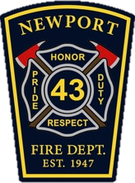
Town of Newport Fire Department is accepting applications for full-time FF/EMT-Basic positions. Position works a 48/96 schedule. Our department covers a seventy five square mile area with a steadily increasing call volume of over 2300 in 2019.
Minimum Qualifications:

Applicants must possess:
High school diploma, Valid Class B NC Driver’s License, NC EVD
NCOEMS credential of EMT-Basic, BLS CPR
NC FF II for a minimum of 2 years, Haz - Mat Ops, and OSFM Driver/Operator Pumps certification
Applicants must also possess (NIMS) ICS 100, 200, 700 and 800.

Applicants must be physically capable of carrying out the duties that firefighting and EMS require.
To apply: Email applications and resumes to, Fire Chief Benny Whitley at bwhitley@townofnewport.com Applications can be found at www.newportnc.gov by following the “CAREER” link and selecting the Application tab. You may also submit application in person to 125 Howard Blvd Newport NC 28570
Starting Pay $40,300 with built in overtime.
OPEN UNTIL FILLED!!!

